**Experiment 8:**

**Aim: ALP to find minimum and maximum from a given array.**

**Code:**

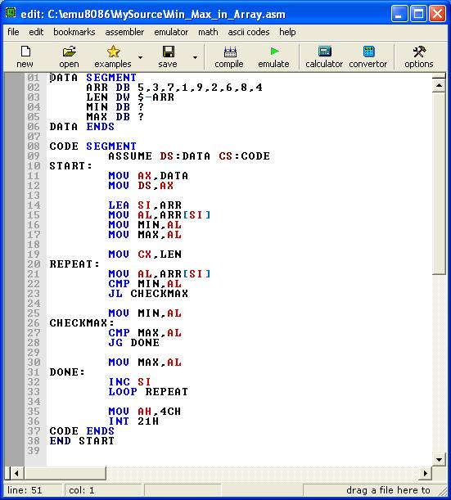

**Output:**

